# results

*Exponential Smoothing Model*

After evaluating the five candidate models on the validation data, we determined that the Holt/Winters model with additive seasonality minimized the mean absolute percentage error (MAPE), with a measure of 15.98%. Consolidating the training and validation data, the same ESM was then refit on this combined data set and used with the test data to assess model accuracy, where the calculated MAPE was approximately 12.54%.

*Decomposition & Visualizations*

Initial investigation and visualization of the training data revealed noticeable seasonality with a magnitude of variation that appeared to remain *roughly* constant across time, indicating an additive seasonality (displayed in Figure 1). Given these features, we used an STL decomposition to extract the trend, seasonality, and error components from the training data set.

**Figure 1:** Generated energyover time in training data set.

Actual *energy* values were overlaid with the trend/cycle component and are displayed in Figure 2. An analogous plot of actual *energy* values overlaid with seasonally adjusted electricity values (seasonality component removed) is shown in Figure 3.

**Figure 2:** Overlay of actual energy values and trend component of training data set.

**Figure 3:** Overlay of actual energy values and seasonally adjusted energy values of training data set.

*Predicted Values*

Upon combining training and validation data to refit the selected Holt/Winters additive exponential smoothing model, a five-month projection was made and plotted alongside test data values over the same interval. These plots are displayed in Figure 4. In addition, a 12-month projection was also made using a model fit solely on the training data and is also shown below alongside the 12 monthly observations of validation data (Figure 5).

**Figure 4:** Time plot of predicted energy values and observed energy values using test data set.

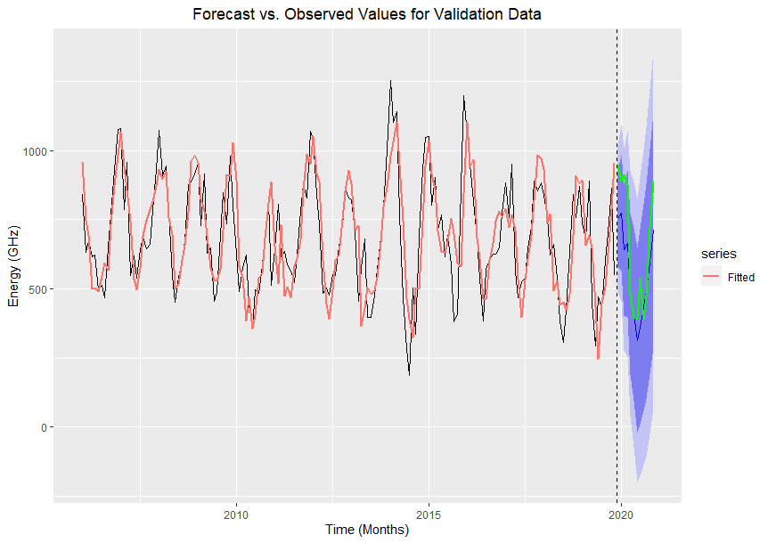

**Figure 5:** Time plot of predicted energy values and observed energy values using validation data set.